**Steps to Run Python Executable (.exe) File**

**Steps to perform before running the Python .exe file: -**

1) Sync RMG Project Share Point to our local system.

(a) To Sync **CSST Data**, use below link to open the share point and click on sync icon 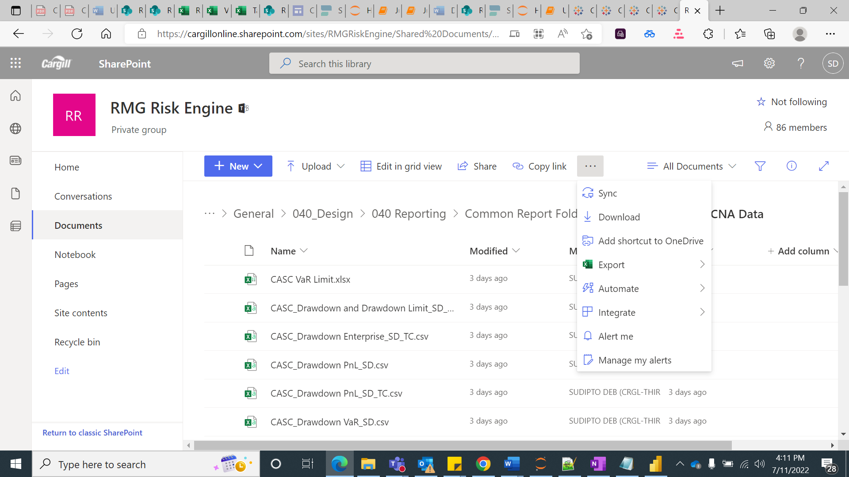 to start the sync process for your local.

[RMG Risk Engine - CSST Data - All Documents (sharepoint.com)](https://cargillonline.sharepoint.com/sites/RMGRiskEngine/Shared%20Documents/Forms/AllItems.aspx?RootFolder=%2Fsites%2FRMGRiskEngine%2FShared%20Documents%2FGeneral%2F040%5FDesign%2F040%20Reporting%2FCommon%20Report%20Folder%2F040%20Queries%2FCSST%20Data&FolderCTID=0x0120001C684613A4D51746BD79E1458267D913)

(b) To Sync **CASCNA Data**, use below link to open the share point and click on sync icon to start sync.

[RMG Risk Engine - CASCNA Data - All Documents (sharepoint.com)](https://cargillonline.sharepoint.com/sites/RMGRiskEngine/Shared%20Documents/Forms/AllItems.aspx?FolderCTID=0x0120001C684613A4D51746BD79E1458267D913&id=%2Fsites%2FRMGRiskEngine%2FShared%20Documents%2FGeneral%2F040%5FDesign%2F040%20Reporting%2FCommon%20Report%20Folder%2F040%20Queries%2FCASCNA%20Data&viewid=be609096%2Dd351%2D4d8a%2Daad9%2D55b365fe5245)

2) You should have **Anaconda3** installed to your system.

3) Once Anaconda3 is installed to your system, you have to install a **ChromeDriver**.

4) So, to do this, kindly check your current **Google Chrome version** which you are using.

To check the Chrome version, open Chrome -> Go to “**Settings**” and click to open it.

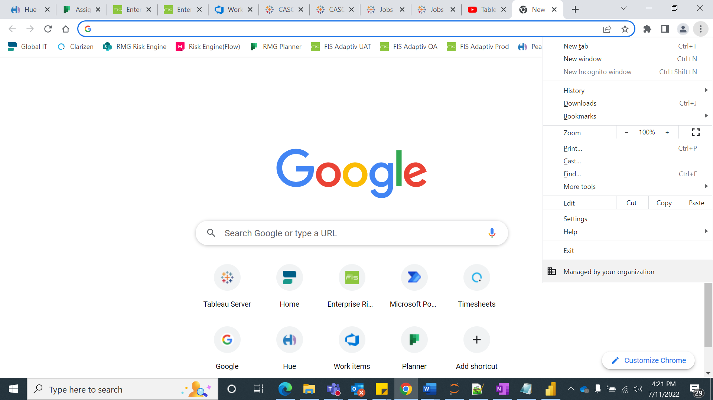

Then, go to “**About Chrome**” -> check the Chrome version. (Use below screenshot, to follow the step)

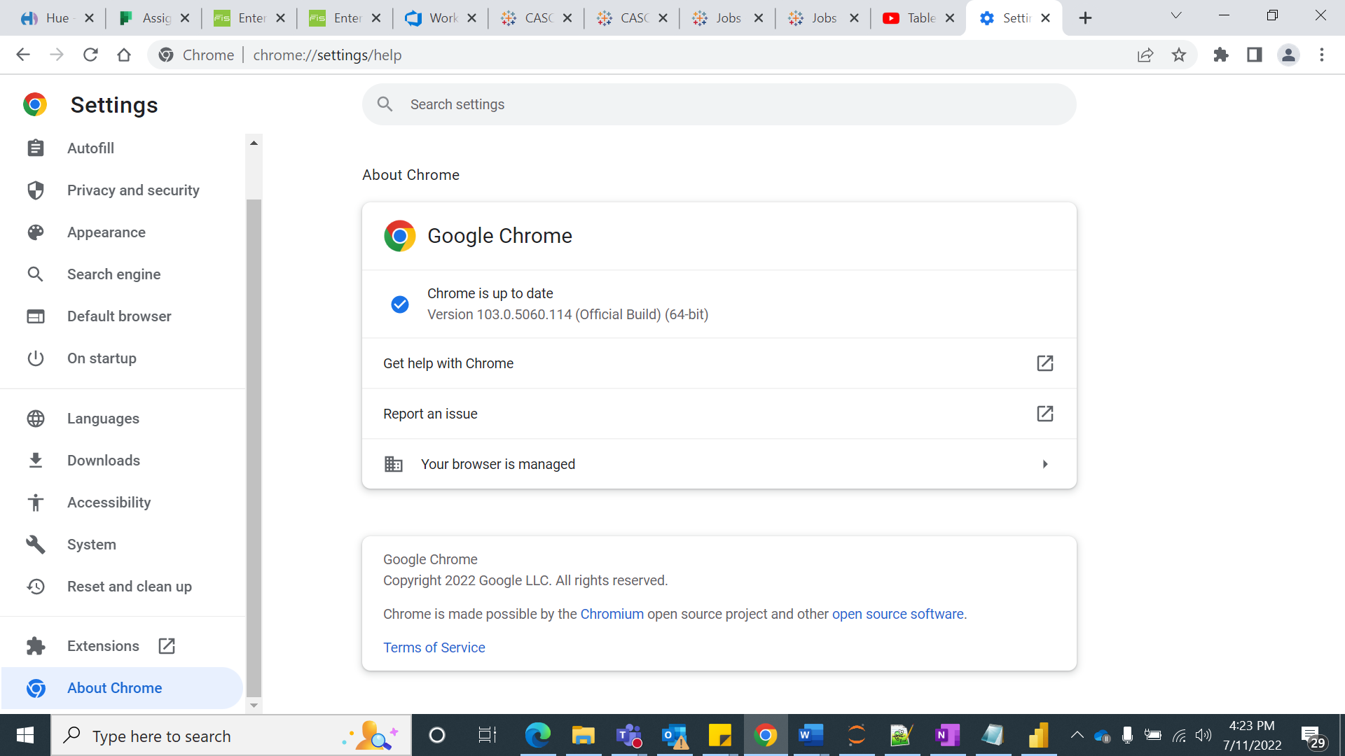

5) Once you have taken your Chrome version number, then use below link to download the ChromeDriver.

[ChromeDriver - WebDriver for Chrome (google.com)](https://sites.google.com/chromium.org/driver/)

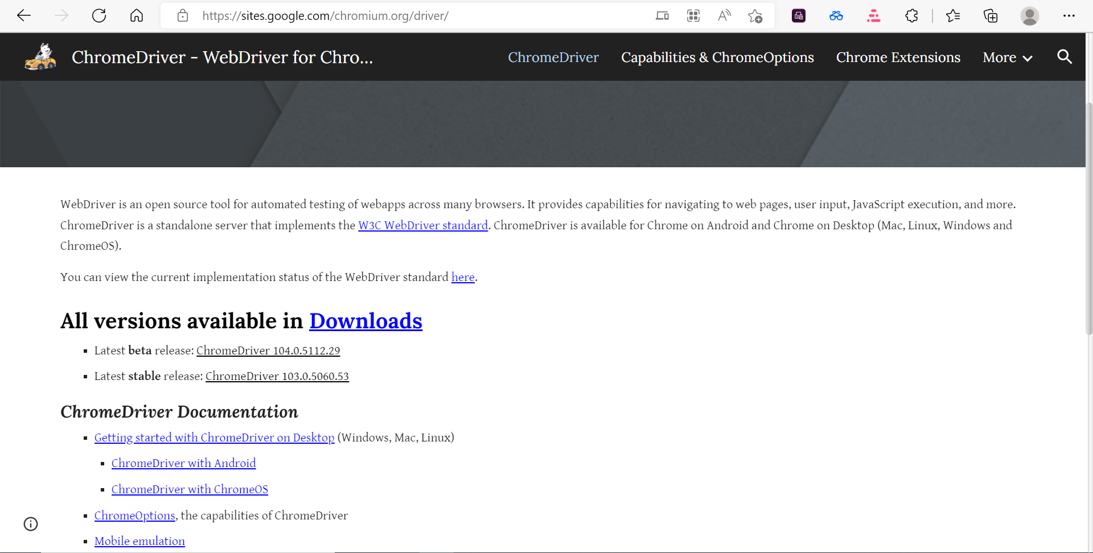

a) Download the ChromeDriver version from the highlighted area based on your Google Chrome version.

b) To download the driver, click on the version which you want to download, then in the next page use ([chromedriver_win32.zip](https://chromedriver.storage.googleapis.com/103.0.5060.53/chromedriver_win32.zip)) this option to download driver. (Use below screenshot to download the correct driver)

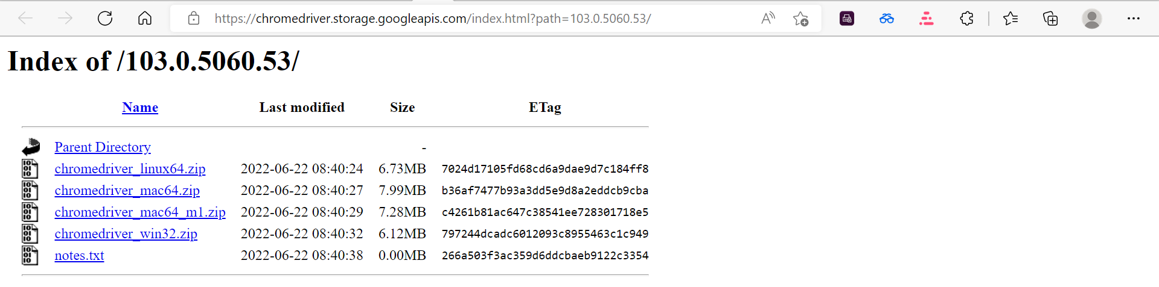

c) Once the ChromeDriver is downloaded, it will be in a zip format. So, please unzip it. (Right click-> Extract All)

6) Once downloaded the driver. Go to the **File Explorer** -> Open **C:\** Drive -> go to **Program Data** -> open **Anaconda3** ->paste the “**chromedriver.exe”.**

**------------------------------------------------------------------------------------------------------------------------------------------**

**Steps to run Python Executable file: -**

1) Use below link to download the CASCNA & CSST executable files.

[CASCNA_Python exe.zip](https://cargillonline.sharepoint.com/:u:/s/RMGRiskEngine/EeQVrMldmPhKsclFyC8oI04B_uP88ALwhoo2Qqkpw_dmcA?e=33pxN2)

[CSST_Python exe.zip](https://cargillonline.sharepoint.com/:u:/s/RMGRiskEngine/EVIr32zix9JOpE1dnE2caDwBKjlY2_wVk2ATPZiXqxA2mA?e=SsNaJW)

2) Once downloaded, right click on the file and choose “**Extract All**” to unzip it.

3) Then open the file -> go inside “**dist**” folder -> there you will find the .exe files like below:

 **&**  respectively.

4) Double click on the **.exe** files to run.

5) When the file start running, it will open a prompt to execute the Python script. In some time, it will ask for a “**Password**” like below:

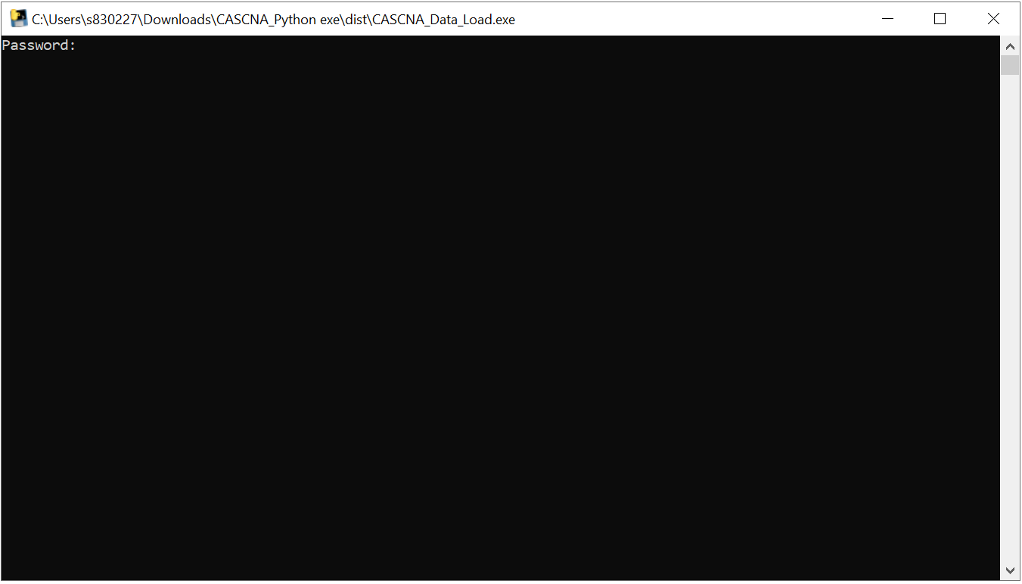

Type your system Password and hit “Enter” to continue the run.

6) Then the file will take sometime to run the complete script and it will bring all the latest data from Adaptiv and store it in the share point location for CASCNA & CSST respectively.

7) Then close the prompt. Execution complete.

---------------------------------------------------------- X ---------------------------------------------------------------------